😊 ACN Mentor Mateo
ELEVEN LABS

2. PLAN CREATOR
22 USD – ~88.000 COP
100.000 créditos al mes
Distribución con 5 estudiantes:
100.000 ÷ 5 = 20.000 caracteres por estudiante
20.000 ÷ 5.000 = 4 audios por estudiante
Cada audio ≈ 5 minutos
Total mensual por estudiante:
≈ 4 audios
≈ 20 minutos de audio
Conclusión:
Este plan permite 1 audio semanal por estudiante.
Es el punto ideal para iniciar ACN Institute con valor diferencial.

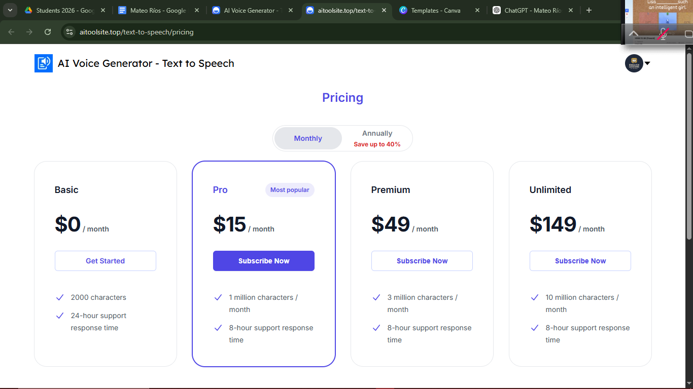
https://speechify.com/onboarding/nc/general/paywall-gtp-2/?website_page=text-to-speech-online&source_page=_text-to-speech-online_&source_category=text-to-speech-online&source_locale=en&source_section=header&selected=gwyneth&name=chatgpt

😊 To-Do List – ACN Institute
✅ To-Do List – ACN Institute

• Averiguar cuánto vale el Audio Tool
• Hacer la Misión de ACN Institute
• Hacer la Visión de ACN Institute
• Definir el Propósito de ACN Institute
• Revisar el Modelo de Negocio con Canvas
• Video Golden Circle Simon Zine

😌 Golden circle
How do you explain when things don't go as we assume? Or better, how do you explain when others are able to achieve things that seem to defy all of the assumptions? For example: Why is Apple so innovative? Year after year, after year, they're more innovative than all their competition. And yet, they're just a computer company. They're just like everyone else. They have the same access to the same talent, the same agencies, the same consultants, the same media. Then why is it that they seem to have something different? Why is it that Martin Luther King led the Civil Rights Movement? He wasn't the only man who suffered in pre-civil rights America, and he certainly wasn't the only great orator of the day. Why him? And why is it that the Wright brothers were able to figure out controlled, powered man flight when there were certainly other teams who were better qualified, better funded -- and they didn't achieve powered man flight, and the Wright brothers beat them to it. There's something else at play here.
01:09
About three and a half years ago, I made a discovery. And this discovery profoundly changed my view on how I thought the world worked, and it even profoundly changed the way in which I operate in it. As it turns out, there's a pattern. As it turns out, all the great inspiring leaders and organizations in the world, whether it's Apple or Martin Luther King or the Wright brothers, they all think, act and communicate the exact same way. And it's the complete opposite to everyone else. All I did was codify it, and it's probably the world's simplest idea. I call it the golden circle.
01:59
Why? How? What? This little idea explains why some organizations and some leaders are able to inspire where others aren't. Let me define the terms really quickly. Every single person, every single organization on the planet knows what they do, 100 percent. Some know how they do it, whether you call it your differentiated value proposition or your proprietary process or your USP. But very, very few people or organizations know why they do what they do. And by "why" I don't mean "to make a profit." That's a result. It's always a result. By "why," I mean: What's your purpose? What's your cause? What's your belief? Why does your organization exist? Why do you get out of bed in the morning? And why should anyone care? As a result, the way we think, we act, the way we communicate is from the outside in, it's obvious. We go from the clearest thing to the fuzziest thing. But the inspired leaders and the inspired organizations -- regardless of their size, regardless of their industry -- all think, act and communicate from the inside out.
03:06
Let me give you an example. I use Apple because they're easy to understand and everybody gets it. If Apple were like everyone else, a marketing message from them might sound like this: "We make great computers. They're beautifully designed, simple to use and user friendly. Want to buy one?" "Meh." That's how most of us communicate. That's how most marketing and sales are done, that's how we communicate interpersonally. We say what we do, we say how we're different or better and we expect some sort of a behavior, a purchase, a vote, something like that. Here's our new law firm: We have the best lawyers with the biggest clients, we always perform for our clients. Here's our new car: It gets great gas mileage, it has leather seats. Buy our car. But it's uninspiring.
03:52
Here's how Apple actually communicates. "Everything we do, we believe in challenging the status quo. We believe in thinking differently. The way we challenge the status quo is by making our products beautifully designed, simple to use and user friendly. We just happen to make great computers. Want to buy one?" Totally different, right? You're ready to buy a computer from me. I just reversed the order of the information. What it proves to us is that people don't buy what you do; people buy why you do it.
04:28
This explains why every single person in this room is perfectly comfortable buying a computer from Apple. But we're also perfectly comfortable buying an MP3 player from Apple, or a phone from Apple, or a DVR from Apple. As I said before, Apple's just a computer company. Nothing distinguishes them structurally from any of their competitors. Their competitors are equally qualified to make all of these products. In fact, they tried. A few years ago, Gateway came out with flat-screen TVs. They're eminently qualified to make flat-screen TVs. They've been making flat-screen monitors for years. Nobody bought one. Dell came out with MP3 players and PDAs, and they make great quality products, and they can make perfectly well-designed products -- and nobody bought one. In fact, talking about it now, we can't even imagine buying an MP3 player from Dell. Why would you buy one from a computer company? But we do it every day. People don't buy what you do; they buy why you do it. The goal is not to do business with everybody who needs what you have. The goal is to do business with people who believe what you believe.
05:39
Here's the best part: None of what I'm telling you is my opinion. It's all grounded in the tenets of biology. Not psychology, biology. If you look at a cross-section of the human brain, from the top down, the human brain is actually broken into three major components that correlate perfectly with the golden circle. Our newest brain, our Homo sapien brain, our neocortex, corresponds with the "what" level. The neocortex is responsible for all of our rational and analytical thought and language. The middle two sections make up our limbic brains, and our limbic brains are responsible for all of our feelings, like trust and loyalty. It's also responsible for all human behavior, all decision-making, and it has no capacity for language.
06:27
In other words, when we communicate from the outside in, yes, people can understand vast amounts of complicated information like features and benefits and facts and figures. It just doesn't drive behavior. When we can communicate from the inside out, we're talking directly to the part of the brain that controls behavior, and then we allow people to rationalize it with the tangible things we say and do. This is where gut decisions come from. Sometimes you can give somebody all the facts and figures, and they say, "I know what all the facts and details say, but it just doesn't feel right." Why would we use that verb, it doesn't "feel" right? Because the part of the brain that controls decision-making doesn't control language. The best we can muster up is, "I don't know. It just doesn't feel right." Or sometimes you say you're leading with your heart or soul. I hate to break it to you, those aren't other body parts controlling your behavior. It's all happening here in your limbic brain, the part of the brain that controls decision-making and not language.
07:21
But if you don't know why you do what you do, and people respond to why you do what you do, then how will you ever get people to vote for you, or buy something from you, or, more importantly, be loyal and want to be a part of what it is that you do. The goal is not just to sell to people who need what you have; the goal is to sell to people who believe what you believe. The goal is not just to hire people who need a job; it's to hire people who believe what you believe. I always say that, you know, if you hire people just because they can do a job, they'll work for your money, but if they believe what you believe, they'll work for you with blood and sweat and tears. Nowhere else is there a better example than with the Wright brothers.
08:06
Most people don't know about Samuel Pierpont Langley. And back in the early 20th century, the pursuit of powered man flight was like the dot com of the day. Everybody was trying it. And Samuel Pierpont Langley had, what we assume, to be the recipe for success. Even now, you ask people, "Why did your product or why did your company fail?" and people always give you the same permutation of the same three things: under-capitalized, the wrong people, bad market conditions. It's always the same three things, so let's explore that. Samuel Pierpont Langley was given 50,000 dollars by the War Department to figure out this flying machine. Money was no problem. He held a seat at Harvard and worked at the Smithsonian and was extremely well-connected; he knew all the big minds of the day. He hired the best minds money could find and the market conditions were fantastic. The New York Times followed him around everywhere, and everyone was rooting for Langley. Then how come we've never heard of Samuel Pierpont Langley?
09:08
A few hundred miles away in Dayton, Ohio, Orville and Wilbur Wright, they had none of what we consider to be the recipe for success. They had no money; they paid for their dream with the proceeds from their bicycle shop. Not a single person on the Wright brothers' team had a college education, not even Orville or Wilbur. And The New York Times followed them around nowhere.
09:30
The difference was, Orville and Wilbur were driven by a cause, by a purpose, by a belief. They believed that if they could figure out this flying machine, it'll change the course of the world. Samuel Pierpont Langley was different. He wanted to be rich, and he wanted to be famous. He was in pursuit of the result. He was in pursuit of the riches. And lo and behold, look what happened. The people who believed in the Wright brothers' dream worked with them with blood and sweat and tears. The others just worked for the paycheck. They tell stories of how every time the Wright brothers went out, they would have to take five sets of parts, because that's how many times they would crash before supper.
10:12
And, eventually, on December 17th, 1903, the Wright brothers took flight, and no one was there to even experience it. We found out about it a few days later. And further proof that Langley was motivated by the wrong thing: the day the Wright brothers took flight, he quit. He could have said, "That's an amazing discovery, guys, and I will improve upon your technology," but he didn't. He wasn't first, he didn't get rich, he didn't get famous, so he quit.
10:43
People don't buy what you do; they buy why you do it. If you talk about what you believe, you will attract those who believe what you believe.
10:50
But why is it important to attract those who believe what you believe? Something called the law of diffusion of innovation, if you don't know the law, you know the terminology. The first 2.5% of our population are our innovators. The next 13.5% of our population are our early adopters. The next 34% are your early majority, your late majority and your laggards. The only reason these people buy touch-tone phones is because you can't buy rotary phones anymore.
11:20
(Laughter)
11:22
We all sit at various places at various times on this scale, but what the law of diffusion of innovation tells us is that if you want mass-market success or mass-market acceptance of an idea, you cannot have it until you achieve this tipping point between 15 and 18 percent market penetration, and then the system tips. I love asking businesses, "What's your conversion on new business?" They love to tell you, "It's about 10 percent," proudly. Well, you can trip over 10% of the customers. We all have about 10% who just "get it." That's how we describe them, right? That's like that gut feeling, "Oh, they just get it."
11:57
The problem is: How do you find the ones that get it before doing business versus the ones who don't get it? So it's this here, this little gap that you have to close, as Jeffrey Moore calls it, "Crossing the Chasm" -- because, you see, the early majority will not try something until someone else has tried it first. And these guys, the innovators and the early adopters, they're comfortable making those gut decisions. They're more comfortable making those intuitive decisions that are driven by what they believe about the world and not just what product is available. These are the people who stood in line for six hours to buy an iPhone when they first came out, when you could have bought one off the shelf the next week. These are the people who spent 40,000 dollars on flat-screen TVs when they first came out, even though the technology was substandard. And, by the way, they didn't do it because the technology was so great; they did it for themselves. It's because they wanted to be first. People don't buy what you do; they buy why you do it and what you do simply proves what you believe. In fact, people will do the things that prove what they believe. The reason that person bought the iPhone in the first six hours, stood in line for six hours, was because of what they believed about the world, and how they wanted everybody to see them: they were first. People don't buy what you do; they buy why you do it.
13:19
So let me give you a famous example, a famous failure and a famous success of the law of diffusion of innovation. First, the famous failure. It's a commercial example. As we said before, the recipe for success is money and the right people and the right market conditions. You should have success then. Look at TiVo. From the time TiVo came out about eight or nine years ago to this current day, they are the single highest-quality product on the market, hands down, there is no dispute. They were extremely well-funded. Market conditions were fantastic. I mean, we use TiVo as verb. I TiVo stuff on my piece-of-junk Time Warner DVR all the time.
13:57
(Laughter)
14:00
But TiVo's a commercial failure. They've never made money. And when they went IPO, their stock was at about 30 or 40 dollars and then plummeted, and it's never traded above 10. In fact, I don't think it's even traded above six, except for a couple of little spikes.
14:15
Because you see, when TiVo launched their product, they told us all what they had. They said, "We have a product that pauses live TV, skips commercials, rewinds live TV and memorizes your viewing habits without you even asking." And the cynical majority said, "We don't believe you. We don't need it. We don't like it. You're scaring us."
14:40
What if they had said, "If you're the kind of person who likes to have total control over every aspect of your life, boy, do we have a product for you. It pauses live TV, skips commercials, memorizes your viewing habits, etc., etc." People don't buy what you do; they buy why you do it, and what you do simply serves as the proof of what you believe.
15:04
Now let me give you a successful example of the law of diffusion of innovation. In the summer of 1963, 250,000 people showed up on the mall in Washington to hear Dr. King speak. They sent out no invitations, and there was no website to check the date. How do you do that? Well, Dr. King wasn't the only man in America who was a great orator. He wasn't the only man in America who suffered in a pre-civil rights America. In fact, some of his ideas were bad. But he had a gift. He didn't go around telling people what needed to change in America. He went around and told people what he believed. "I believe, I believe, I believe," he told people. And people who believed what he believed took his cause, and they made it their own, and they told people. And some of those people created structures to get the word out to even more people. And lo and behold, 250,000 people showed up on the right day at the right time to hear him speak.
16:08
How many of them showed up for him? Zero. They showed up for themselves. It's what they believed about America that got them to travel in a bus for eight hours to stand in the sun in Washington in the middle of August. It's what they believed, and it wasn't about black versus white: 25% of the audience was white.
16:30
Dr. King believed that there are two types of laws in this world: those that are made by a higher authority and those that are made by men. And not until all the laws that are made by men are consistent with the laws made by the higher authority will we live in a just world. It just so happened that the Civil Rights Movement was the perfect thing to help him bring his cause to life. We followed, not for him, but for ourselves. By the way, he gave the "I have a dream" speech, not the "I have a plan" speech.
16:59
(Laughter)
17:03
Listen to politicians now, with their comprehensive 12-point plans. They're not inspiring anybody. Because there are leaders and there are those who lead. Leaders hold a position of power or authority, but those who lead inspire us. Whether they're individuals or organizations, we follow those who lead, not because we have to, but because we want to. We follow those who lead, not for them, but for ourselves. And it's those who start with "why" that have the ability to inspire those around them or find others who inspire them.
17:44
Thank you very much.
17:45

Main Ideas
How Great Leaders Inspire Action
1. Pregunta central
El autor plantea una inquietud fundamental: por qué algunas personas y organizaciones logran resultados extraordinarios aun cuando cuentan con los mismos recursos, talento y oportunidades que sus competidores.
Se concluye que el éxito no depende únicamente de dinero, tecnología o habilidades técnicas, sino de un factor más profundo relacionado con la motivación y el propósito.

2. El modelo del Golden Circle
Sinek introduce un marco conceptual llamado Golden Circle, compuesto por tres niveles:
- WHY: propósito, causa o creencia
- HOW: proceso o enfoque diferencial
- WHAT: producto o servicio
La mayoría de organizaciones comunican de afuera hacia adentro (WHAT → HOW → WHY).
Los líderes inspiradores comunican de adentro hacia afuera (WHY → HOW → WHAT).
Este cambio en el orden genera mayor conexión emocional e inspiración.

3. El poder del propósito
La idea central del discurso es:
People don’t buy what you do; they buy why you do it.
Las personas no se sienten atraídas únicamente por características técnicas o beneficios funcionales, sino por las creencias, valores y propósito detrás de una acción u organización.
El propósito genera lealtad, confianza y compromiso a largo plazo.

4. Ejemplo empresarial
Se utiliza el caso de Apple Inc. para mostrar cómo una empresa comunica primero su filosofía (“think differently”) y luego sus productos.
Aunque otras compañías pueden fabricar tecnología similar, Apple logra mayor fidelidad porque vende una identidad y una visión, no solo dispositivos.

5. Fundamento biológico de la decisión
El modelo también se apoya en la estructura del cerebro humano:
- El neocórtex procesa lógica, datos y lenguaje
- El sistema límbico procesa emociones, confianza y decisiones
Las decisiones se toman principalmente de manera emocional y luego se justifican racionalmente. Por ello, los mensajes basados en propósito influyen más que los basados únicamente en información técnica.

6. Caso de liderazgo histórico
El discurso compara a Orville Wright y Wilbur Wright con Samuel Pierpont Langley.
Langley contaba con más recursos y respaldo institucional, pero buscaba fama y resultados personales.
Los Wright estaban motivados por una creencia clara y un propósito.
La conclusión es que las personas se comprometen más profundamente cuando comparten una causa, no solo un salario o un beneficio externo.

7. Difusión de la innovación
Se explica la ley de difusión de la innovación:
- Innovators
- Early adopters
- Early majority
- Late majority
- Laggards
El éxito masivo ocurre cuando primero se atrae a quienes creen en la misma visión. Estos grupos iniciales influyen posteriormente en el resto del mercado.

8. Concepto de liderazgo
Se distingue entre:
- Leaders: personas con autoridad formal
- Those who lead: personas que inspiran
La inspiración, no la jerarquía, es lo que moviliza a otros a actuar voluntariamente.
El ejemplo de Martin Luther King Jr. demuestra que las personas siguieron su causa porque compartían sus creencias, no porque existiera obligación.

Conclusión
Las organizaciones y líderes más efectivos comienzan definiendo claramente su propósito.
Cuando el mensaje parte del “por qué”, se genera conexión emocional, lealtad y acción sostenida.
El liderazgo inspirador se construye sobre creencias compartidas, no únicamente sobre productos, planes o autoridad.

Here is a short, professional summary of the main ideas from How Great Leaders Inspire Action by Simon Sinek:

Main Ideas – How Great Leaders Inspire Action
1. Core question
Some leaders and organizations consistently outperform others despite having similar resources. The difference is not talent or money, but purpose.
2. The Golden Circle
Effective leaders communicate from the inside out:
WHY (purpose) → HOW (process) → WHAT (product).
Most organizations communicate in the opposite order.
3. Purpose drives action
People do not buy what you do; they buy why you do it. Shared beliefs create trust, loyalty, and long-term commitment.
4. Evidence through examples
Companies like Apple Inc. and leaders such as Martin Luther King Jr. inspire others because they clearly communicate their beliefs and vision, not just features or plans.
5. Key conclusion
Inspiration and leadership begin with a clear purpose. When people believe in your cause, they choose to follow, support, and engage.

☺️ MVP
PROPÓSITO – ACN INSTITUTE
En ACN Institute “Conectamos tu propósito con el mundo a través del inglés.”

MISIÓN – ACN INSTITUTE
En ACN Institute ofrecemos una experiencia de aprendizaje de inglés estratégica, personalizada y significativa, diseñada a partir de las metas, el contexto y el propósito de cada estudiante.
A través de una metodología comunicativa, herramientas digitales y un acompañamiento cercano, creamos planes de aprendizaje personalizados que permiten desarrollar habilidades reales de comunicación en inglés.

VISIÓN – ACN INSTITUTE
Ser un instituto virtual de inglés reconocido por su metodología personalizada y su impacto real en la vida de sus estudiantes.
En ACN queremos formar una comunidad de estudiantes que utilicen el inglés como una herramienta para expandir sus oportunidades, conectar con el mundo y construir el futuro que desean.

FRASE DE MARCA (MUY PODEROSA)
“Conectamos tu propósito con el mundo a través del inglés.”


😌 ACN INSTITUTE GOLDEN C
ACN INSTITUTE
Aplicación del Modelo Golden Circle
Modelo conceptual desarrollado por Simon Sinek

1. WHY (Propósito)
ACN Institute existe para transformar el aprendizaje del inglés en un proceso con propósito, dirección y significado.
Creemos que aprender un idioma no debe ser un proceso genérico, sino una experiencia estratégica alineada con metas personales, académicas y profesionales. Nuestro propósito es empoderar a estudiantes comprometidos para que desarrollen confianza, claridad y autonomía a través de un acompañamiento personalizado y estructurado.
EMPODERAMOS Y GENERAMOS CONFIANZAS

2. HOW (Metodología Diferencial)
ACN Institute implementa un modelo educativo basado en:
- Diagnóstico inicial y creación de perfil individual del estudiante.
- Metodología comunicativa centrada en objetivos reales.
- Diseño de un plan de aprendizaje personalizado según nivel y metas.
- Seguimiento continuo mediante herramientas digitales (Google Drive, documentos compartidos y registro de progreso).
- Adaptación del tiempo del curso según avance y compromiso.
- Acompañamiento estratégico enfocado en resultados medibles.
Nuestro enfoque combina estructura académica, tecnología y personalización total del proceso formativo.

3. WHAT (Oferta de Servicios)
ACN Institute ofrece:
- Clases virtuales de inglés.
- Programas estructurados por niveles (básico, intermedio y avanzado).
- Evaluación diagnóstica inicial.
- Plan de estudio individualizado.
- Material digital organizado.
- Seguimiento académico continuo.
- Estrategias de promoción e inscripción.

Declaración Institucional Integrada (Golden Circle)
En ACN Institute creemos que el aprendizaje del inglés debe tener propósito y dirección. Por ello, diseñamos procesos personalizados basados en las metas y habilidades de cada estudiante, implementando una metodología comunicativa con seguimiento continuo y estructura académica clara. Ofrecemos clases virtuales organizadas por niveles que garantizan un proceso estratégico, medible y alineado con objetivos reales.

📋 CANVA
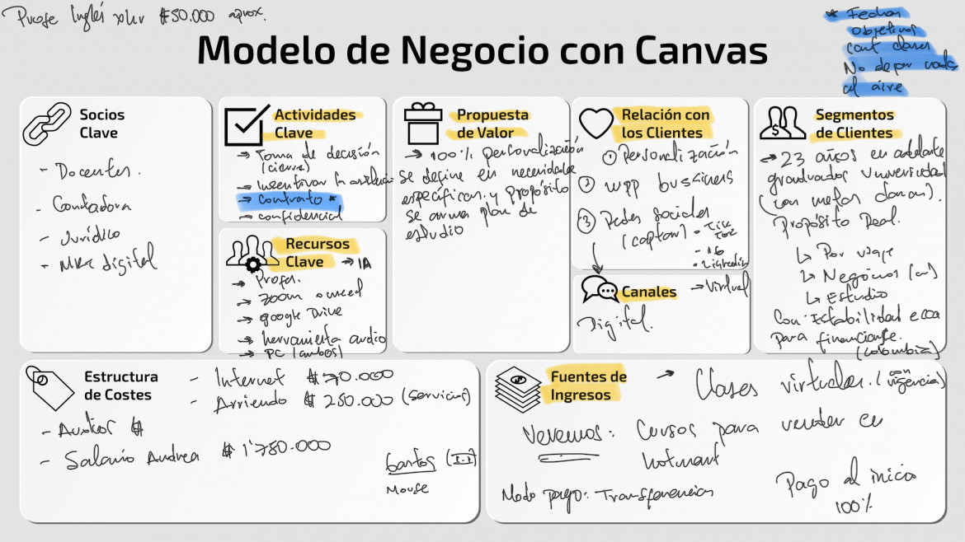

Modelo de Negocio con Canvas

Socios Clave
- Docentes
- Contadores
- Jurídico
- Más difícil

Actividades Clave
- Crear actividades
- Corrección
- Crear contenido
- Marketing / ventas

Recursos Clave
- Página web
- Google Drive
- Inventario de audio
- Plataforma

Propuesta de Valor
- 100% Personalizado
- Metodología que se adapta al estudiante
- Se diseña un plan de estudio según su propósito

Relación con los Clientes
- Muy personalizada
- WhatsApp business
- Clases personalizadas
- Seguimiento del estudiante

Canales
- Instagram
- WhatsApp
- Página web

Segmentos de Clientes
- 23 años en adelante
- Profesionales que quieran mejorar su inglés
- Profesionales con necesidad laboral
- Que necesiten flexibilidad para formación

Estructura de Costes
- Internet: $70.000
- Arriendo: $200.000 (servicio)
- Salario Andrea: $1.780.000
- Bancos

Fuentes de Ingresos
- Clases virtuales: suscripción
- Curso para vender en Hotmart
- Pago de inicio: 100%

😌 Objectivos estratégicos
OBJETIVOS ESTRATÉGICOS:

- PERSPECTIVAS financiero
- PERSPECTIVAS de aprendizajes
- PERSPECTIVAS de clientes
- PERSPECTIVAS de procesos internos. PERSPECTIVAS

DOFA
Enlistar nuestras debilidades, oportunidades, fortalezas y amenazas (OA, amenazas)

Debilidad: fallas con la conexión a internet
Oportunidad: Posibilidades de alianzas educativas
Fortalezas: personalización, acuerdo de entradas a clases. Compromiso real.
Amenazas: demandas de estudiantes, impuestos, gobierno, fenómenos naturales.

Oportunidad: Crear planes de acompañamiento personalizados para instituciones de acuerdo a su propósito.

Fortalezas: Tener planes personalizados nos permite generar un mayor cobro por los servicios educativos

F-A: Personalización-demandas de estudiantes, compromiso y acuerdo mutuo, compromiso con parámetros. Contrato/documento legal que genere claridad antes las políticas de clases y su efectividad.

ESTRETEGIAS::

Cuando tengas estrategias, sacar objetivos, perspectivas

Metodologia Smart

S pecifico responde al QUE
M de medible, nos responde al CUANTO
A alcanzable, COMO
R, real, PARA QUE
T: Tiempo, CUANDO.
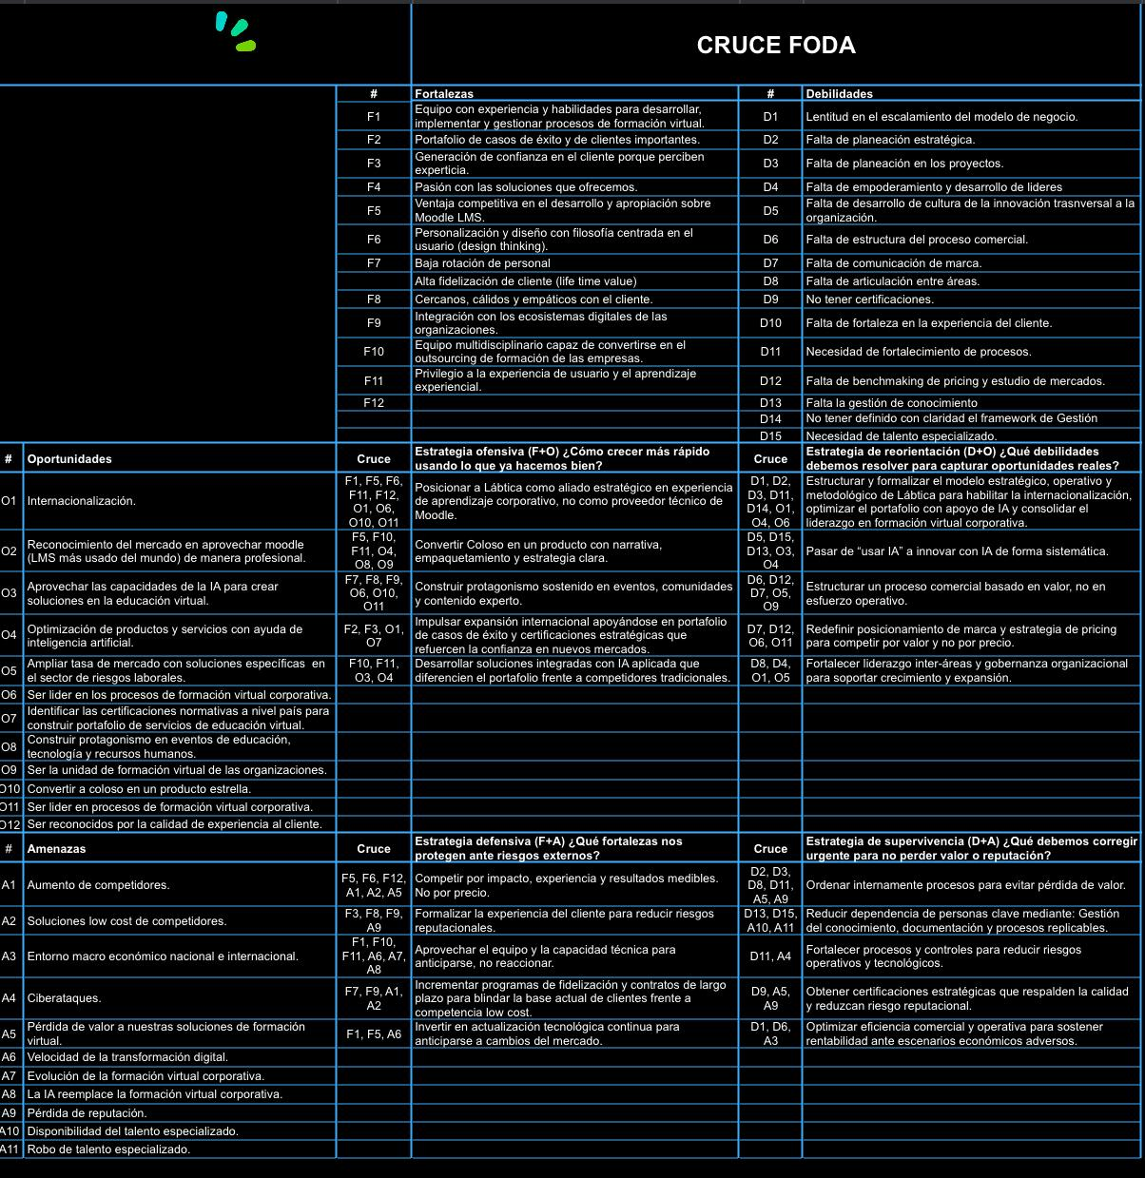

😊 DOFA ACN
ANÁLISIS (MATRIZ DOFA ESTRATÉGICA) ACN
Matriz DOFA ampliada con cruces estratégicos (FO, DO, FA, DA). Cuatro bloques principales:
FORTALEZAS (F)
F1. Experiencia en formación virtual
F2. Portafolio de casos de éxito
F3. Confianza generada en clientes
F4. Pasión por las soluciones
F5. Desarrollo y apropiación del modelo
F6. Personalización 100 % centrada en usuario
F7. Baja rotación de personal
F8. Alta fidelización de clientes
F9. Cercanía y empatía con clientes
F10. Integración con dinámicas organizacionales
F11. Enfoque en experiencia de aprendizaje
DEBILIDADES (D)
D1. Lentitud en escalamiento
D2. Falta de planeación estratégica
D3. Falta de planeación en proyectos
D4. Falta de empoderamiento de líderes
D5. Falta de cultura de innovación
D6. Falta de estructura comercial
D7. Falta de comunicación de marca
D8. Falta de articulación interna
D9. Falta de certificaciones
D10. Debilidad en experiencia del cliente
D11. Procesos débiles
D12. Falta de benchmarking de precios. Proceso estratégico y continuo de investigación y análisis comparativo.
D13. Falta de gestión del conocimiento
D14. Falta de framework claro
D15. Falta de talento especializado
OPORTUNIDADES (O)
O1. Internacionalización
O2. Crecimiento del uso de LMS. Learning Management System o Sistema de Gestión de Aprendizaje
O3. Uso de IA en educación
O4. Optimización con inteligencia artificial
O5. Nichos específicos de mercado
O6. Liderazgo en formación virtual
O7. Certificaciones normativas
O8. Eventos y posicionamiento
O9. Unidad de formación virtual
O10. Producto estrella, ACN INSTITUTO, INGLÉS CON PROPÓSITO
O11. Liderazgo corporativo
O12. Reconocimiento por experiencia
AMENAZAS (A)
A1. Aumento de competidores
A2. Competencia low cost
A3. Entorno económico
A4. Ciberataques
A5. Pérdida de valor percibido
A6. Transformación digital acelerada
A7. Evolución del sector
A8. Reemplazo por IA
A9. Pérdida de reputación
A10. Falta de talento
A11. Fuga de talento

CRUCES ESTRATÉGICOS
TIPOS DE ESTRATEGIAS
FO (OFENSIVA)
FO — Estrategias Ofensivas
(Fortalezas + Oportunidades)
Usan las fortalezas de la empresa para aprovechar oportunidades del entorno.
Pregunta clave:
¿Cómo usamos lo que hacemos bien para crecer más?
Ejemplo:
Usar la personalización del servicio (fortaleza) para crear alianzas educativas (oportunidades).
Resultado:
Crecimiento, expansión y posicionamiento.
Uso de IA como diferenciador, en un entorno de aprendizaje personalizado.
DO (REORIENTACIÓN)
(Debilidades + Oportunidades)
DO — Estrategias de Reorientación
(Debilidades + Oportunidades)
Buscan corregir debilidades para poder aprovechar oportunidades.
Pregunta clave:
¿Qué debemos mejorar para aprovechar oportunidades reales?
Ejemplo:
Mejorar la conexión a internet (debilidad) para ofrecer programas virtuales institucionales (oportunidad).
Resultado:
Mejora interna y adaptación.
- Formalizar modelo estratégico
Integrar IA en procesos
Crear estructura comercial basada en valor
Redefinir marca y pricing
FA (DEFENSIVA)
FA — Estrategias Defensivas
(Fortalezas + Amenazas)
Usan fortalezas para protegerse de amenazas externas.
Pregunta clave:
¿Cómo usamos nuestras fortalezas para evitar riesgos?
Ejemplo:
Usar contratos claros y acompañamiento personalizado (fortalezas) para evitar demandas de estudiantes (amenaza).
Resultado:
Protección, estabilidad y reputación.
Competir por experiencia
Formalizar experiencia del cliente
Fidelización con contratos
Inversión en tecnología
DA (SUPERVIVENCIA)
DA — Estrategias de Supervivencia
(Debilidades + Amenazas)
Reducen debilidades y minimizan amenazas para evitar pérdidas.
Pregunta clave:
¿Qué debemos corregir urgentemente para no perder valor o estabilidad?
Ejemplo:
Crear protocolos tecnológicos y legales para evitar problemas por fallas de internet y demandas.
Resultado:
Control de riesgos y sostenibilidad.
Ordenar procesos internos
Reducir dependencia de personas
Fortalecer controles
Obtener certificaciones
Optimizar eficiencia operativa

DOFA COMPLEMENTARIO (TU CONTEXTO)
FORTALEZAS
Personalización del servicio
Compromiso real con estudiantes
Acuerdos claros de ingreso
Capacidad de cobrar más por valor
DEBILIDADES
Fallas en la conexión a internet
OPORTUNIDADES
Alianzas educativas
Planes personalizados para instituciones
AMENAZAS
Demandas de estudiantes
Impuestos
Gobierno
Fenómenos naturales como apagones
Que al estudiante no le guste su profesor

ESTRATEGIAS PROPUESTAS (ARTICULAR A PERSPECTIVAS)
FO
Desarrollar programas educativos personalizados para individuos-instituciones con alianzas estratégicas y precios premium
DO
Invertir en infraestructura tecnológica para reducir fallas de conexión y mejorar experiencia
FA
Formalizar contratos educativos que protejan ante demandas y establezcan reglas claras
DA
Diseñar protocolos operativos y legales para mitigar riesgos externos (legales, naturales, regulatorios)

OBJETIVOS ESTRATÉGICOS (METODOLOGÍA SMART)
PERSPECTIVA FINANCIERA 2 O 3
Objetivo: Incrementar ingresos mediante programas personalizados
GENERAR ALIANZAS INSTTITUCIONESLE
S: Crear programas premium institucionales
M: Aumentar ingresos en %
A: A través de alianzas educativas
R: Mejora rentabilidad del negocio
T: En 12 meses
PERSPECTIVA DE CLIENTES
Objetivo: Mejorar satisfacción y retención
S: Implementar acuerdos y contratos claros
M: Reducir quejas en 40%
A: Mediante protocolos de servicio
R: Mejora experiencia del cliente
T: En 6 meses
PERSPECTIVA DE PROCESOS INTERNOS
Objetivo: Optimizar operación y reducir fallas
S: Mejorar infraestructura tecnológica
M: Reducir fallas de conexión en 80%
A: Inversión en plataformas y soporte
R: Aumenta eficiencia operativa
T: En 4 meses
PERSPECTIVA DE APRENDIZAJE Y CRECIMIENTO
Objetivo: Fortalecer capacidades organizacionales
S: Capacitar equipo en innovación y tecnología educativa
M: 100% del equipo capacitado
A: Programas de formación interna
R: Mejora calidad del servicio
T: En 8 meses
CONCLUSIÓN ESTRATÉGICA
El modelo tiene una base sólida en personalización y experiencia, pero necesita estructuración operativa, tecnológica y legal. La mayor ventaja competitiva está en transformar la personalización en un producto premium escalable, respaldado por procesos claros, tecnología estable y alianzas estratégicas.

☺️ acn_gastos_analisis
acn_gastos_analisis

